MECH 463 - Lab Report #1

1-DOF Vibration Measurement of a Simulated Engine Mounting

**Submitted: November 4, 2019**

**Group 105**

**Ahmad Farhan - 22426150**

**Arjun Vadehra - 20037164**

**Gianni Co - 16131161**

*Group Member Contribution:*

*Ahmad: 33.3%, Arjun: 33.3%, Gianni: 33.3%*

# Table of Contents

**Abstract** **2**

**Introduction and Methodology** **2**

**Results** **3**

**Damping Factor Calculation** **4**

**Damped Natural Frequency** **7**

**Sample Calculations** **7**

**Discussion** **11**

Comparison of Theoretical vs. Actual Values 11

**Conclusions** **12**

# 

# Abstract

Vibrations are prevalent in most mechanical systems. There are good and bad vibrations which is why identification and characterization of systems with vibration is essential for engineers. In this experiment a 1-DOF forced damped spring mass system was analyzed to identify how vibration amplitude and phase change with forcing frequency, along with identifying the natural frequency and damping factor. The models were plotted against the collected data and differentiated between theoretical and experimental data. The 4 counter rotated wheels with varying frequency induced the driving force. Amplitude and relative phase was calculated at each frequency. Due to a combination of systematic error from the measurement tool offset, over-idealization of the system, and resolution of positing the measurement probes, the recorded amplitude was smaller than the theoretical values.

In part II, the natural frequency and damping factors were characterized by striking the system with a mallet and observing the decaying and vibrating properties. Logarithmic decrement theory was employed to create a model for identifying the damping factor of the free underdamped system. Following this several methods of identifying the damped natural frequency were compared, and the best method identified. Both the natural frequency and damped response of the system matched very closely with the theory with the exception of one point which is suspected to be human error. Overall the experiment verifies the accuracy of theory for simple vibrating systems.

# Introduction and Methodology

Uncontrolled vibrations in products and machines are often the cause of failure in function, noise and increased load safety risks. These undesirable effects can be accounted for by proper vibration analysis and designing systems to avoid the prerequisites of this behaviour. The objective of this lab is to investigate the vibrational behaviour of a particular set-up (Seen in figure 1) to better understand the behaviour of vibrating systems including aspects such as resonance.

The particular system considered is excited by the rotation of 2 eccentrically biased masses on counter-rotating shafts The frequency of the rotation and subsequently the vibration forcing was changed by changing the rpm of the motor driving the shafts. The forcing is resisted by 4 springs and 1 damper located at the base of the block. An accelerometer located on top (centre) records the vibrational data.

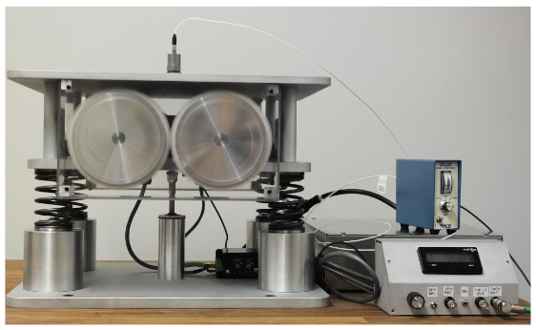

*Figure 1: Lab Apparatus*

The two tasks addressed were

1. Determining how varying forcing frequency (by increasing the rotational speed of eccentric masses) changes resulting system vibrational amplitude and phase lead/lag.
2. Identifying the damping factor by exciting the system with an impact from a rubber mallet. The logarithmic decrement calculation combined with the curve produced by the accelerometer was used to find the damping factor of the setup..

# Results

The software Labview was used to record values such as the amplitude of the vibration and the calculation of the phase. The frequency values were recorded directly from the RPM meter for the motor.

*Table 1: Table of recorded and calculated data*

|  |  |  |  |  |  |
| --- | --- | --- | --- | --- | --- |
| Recorded frequency (rpm) | Recorded Amplitude (V) | Recorded phase | Calculated frequency (hz) | Calculated frequency (rad/s) | Amplitude (mm) |
| 1201.22 | 2.04E-02 | 60.6 | 20.02 | 125.79 | 0.128 |
| 1140.72 | 1.94E-02 | 62.97 | 19.01 | 119.46 | 0.135 |
| 1079.6 | 1.82E-02 | 64.86 | 17.99 | 113.06 | 0.141 |
| 1021.44 | 1.73E-02 | 69.3 | 17.02 | 106.96 | 0.149 |
| 961.59 | 1.63E-02 | 69.65 | 16.03 | 100.7 | 0.159 |
| 899.1 | 1.57E-02 | 74.59 | 14.02 | 94.15 | 0.175 |
| 841.2 | 1.53E-02 | 77.56 | 12.99 | 88.09 | 0.195 |
| 779.6 | 1.54E-02 | 81.41 | 12 | 81.64 | 0.229 |
| 719.92 | 1.67E-02 | 86.3 | 12 | 75.39 | 0.29 |
| 661.2 | 2.01E-02 | 111.54 | 11.02 | 69.24 | 0.414 |
| 599.12 | 3.37E-02 | 123.06 | 9.99 | 62.74 | 0.848 |
| 540.13 | 2.16E-02 | -121.61 | 9 | 56.56 | 0.667 |
| 479.76 | 5.53E-03 | -101.61 | 8 | 50.24 | 0.217 |
| 421.15 | 2.30E-03 | -98.9 | 7.02 | 44.1 | 0.117 |
| 359.18 | 8.13E-04 | -71.66 | 5.99 | 37.61 | 0.057 |
| 299.8 | 4.47E-04 | -23.35 | 5 | 31.39 | 0.045 |
| 240.47 | 3.21E-04 | -21.59 | 4.01 | 25.18 | 0.05 |

Please refer to Sample Calculations for the method used to get values in Table 1.

# Damping Factor Calculation

The damping factor of the system (engine block simulation) was determined in the second section of our experiment by first turning off the rotating eccentric masses (f(t) = 0). We then smacked the setup with the soft end of a rubber mallet. The resulting waveform, as shown in Figure 2 below, was recorded by the accelerometer. We used the method of logarithmic decrements and rate of decay of each peak to calculate for the damping factor.

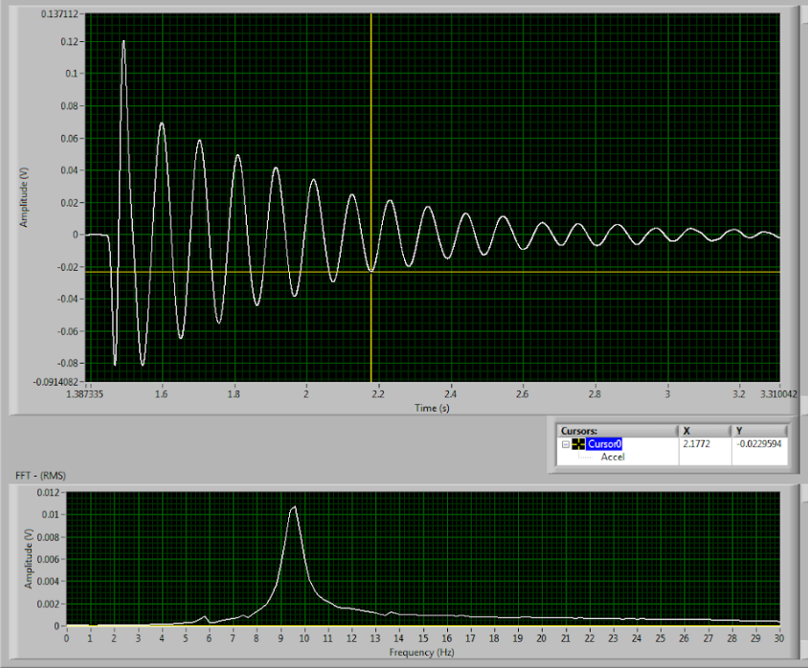

*Figure 2: Raw accelerometer waveform data of the system in part 2*

The logarithmic decrement method uses the following equations below:

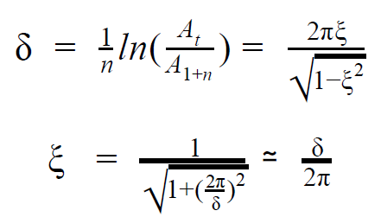

We can then pull the peaks of the accelerometer output and compare their rates of decay as time goes on and the number of waveforms increase. The relationship observed experimentally closely matches theoretical expectations. We skipped the first pairs of peaks (n=0, n=0.5) due to an abnormality in the first negative peak (this is shortly after the mallet struck). A table of these values are shown below.

*Table 2: Vibration peaks when hit by mallet*

|  |  |  |  |  |
| --- | --- | --- | --- | --- |
| n | Amplitude (mm) | Ln(Amplitude) | Time | Log decrement |
| 1 | 0.070 | -2.67 | 1.60 | 0.00 |
| 1.5 | 0.065 | -2.74 | 1.65 | 0.15 |
| 2 | 0.059 | -2.84 | 1.70 | 0.19 |
| 2.5 | 0.054 | -2.91 | 1.75 | 0.15 |
| 3 | 0.049 | -3.02 | 1.81 | 0.21 |
| 3.5 | 0.044 | -3.13 | 1.86 | 0.24 |
| 4 | 0.041 | -3.19 | 1.92 | 0.12 |
| 4.5 | 0.039 | -3.26 | 1.97 | 0.12 |
| 5 | 0.034 | -3.38 | 2.02 | 0.25 |
| 5.5 | 0.029 | -3.54 | 2.07 | 0.32 |
| 6 | 0.025 | -3.69 | 2.13 | 0.30 |
| 6.5 | 0.023 | -3.77 | 2.18 | 0.17 |

A logarithmic plot of amplitude against peak/waveform number has been plotted below based on Table 2 above (Figure 2).

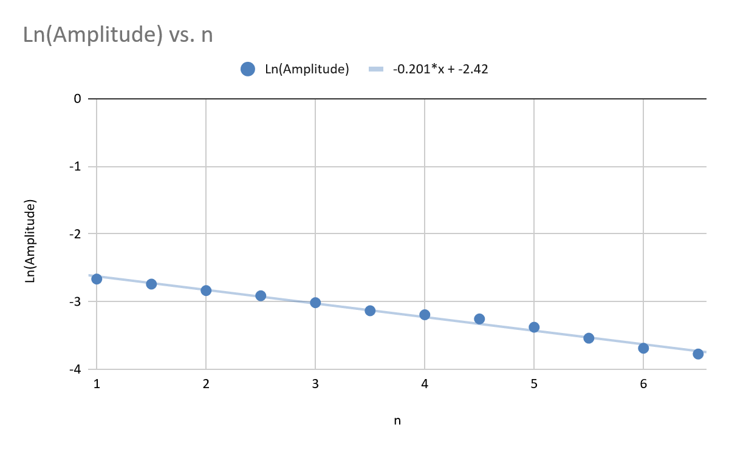

*Figure 3: Logarithmic plot of amplitude against peak number*

We can convert the average logarithmic decrement of the plot (0.201, slope*-1) into the damping factor of the system using one of the equations shown above. The damping factor is calculated to be $ξ=0.201/2π=0.032$.

# Damped Natural Frequency

The damped frequency can be determined in two ways:

1. Divide the number of peaks by the total time interval after converting it into radians per second.
$ω=2πn/Δt=2π*5/(2.13-1.6)=59.3 rad/s$

2. Finding the peak of the amplitude-frequency plot recorded by the accelerometer.

$9.6 Hz = 60.3 rad/s$

The two methods outlined above are in very close agreement with one another, as far as the natural frequency is concerned. To determine the actual natural frequency, the equation below was used in conjunction with the damping factor found in the previous section.

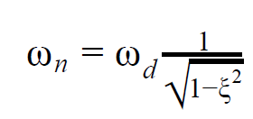

$ω_{n}$ is found to be **60.33 rad/s**, after plugging in 60.3 as the damped frequency, and 0.032 as the damping factor. This is to be expected. Since the damping factor is so low, the damped frequency should very closely match the natural frequency.

# Sample Calculations

The calculations corresponding to table 1 were carried out as follows

The displacement was calculated using the relationship between displacement and acceleration as well as the calibration for the accelerometer.

$a [m/s^{2}] = A [V]/0.0101[V s^{2}/m]$

Where the brackets correspond to units. Furthermore:

$s(m) = a /ω^{2}$

The rad/s frequency is also listed in table 1. Figure 2 represents the displacement vs frequency plot. $ω =2*π*f$.

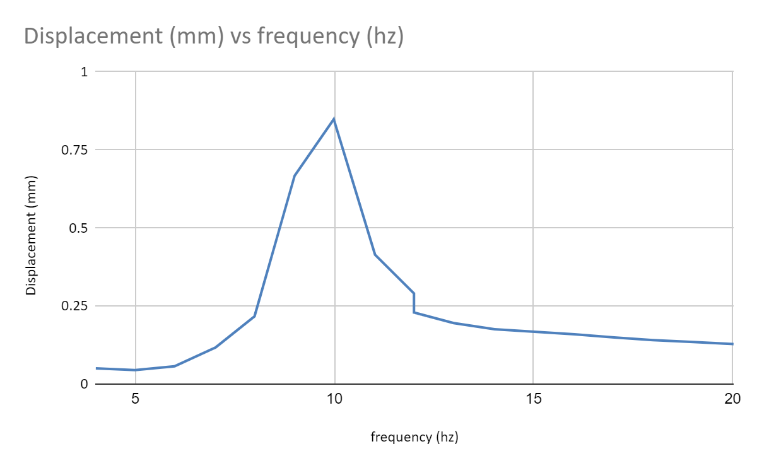

*Figure 4: Displacement vs frequency*

The phase was calculated directly from the LabVIEW plots using cursors to measure wavelength and time differences between pulses and falling zeros.

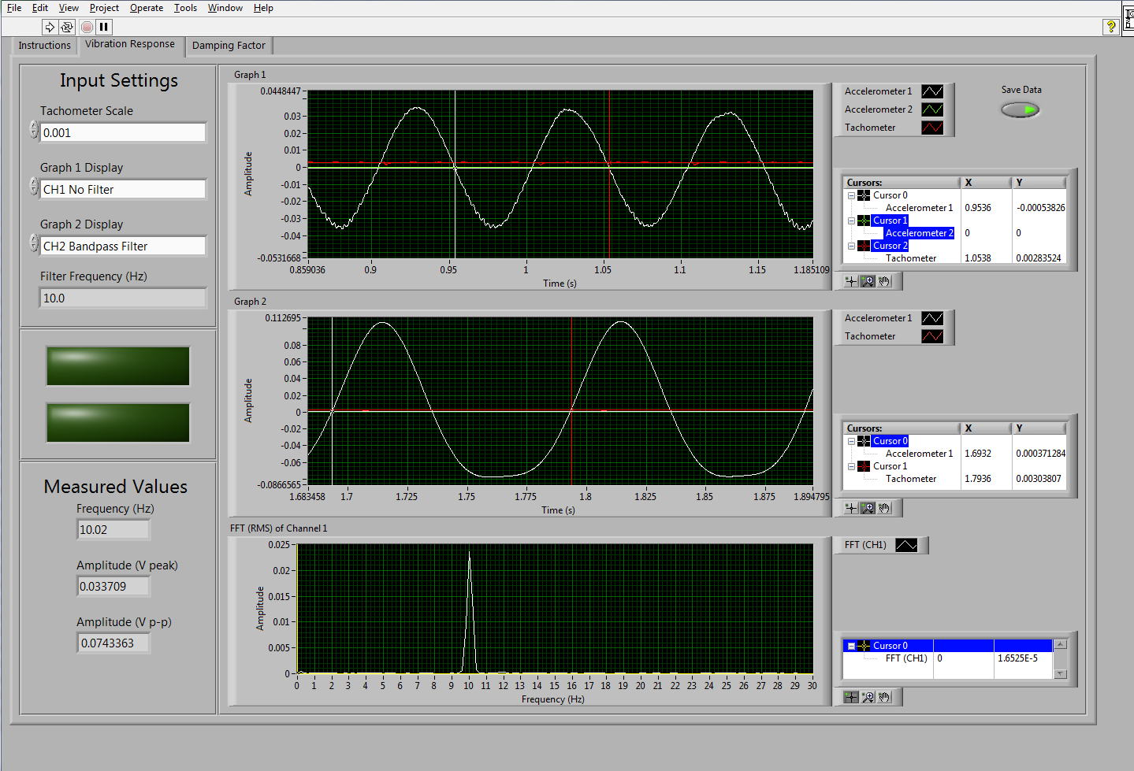

*Figure 5: Sample Labview plot*

Phase lead was calculated as

$ϕ = -360×time to falling zero crossing/time for one wavelength$

Using the sample pot from figure 5,

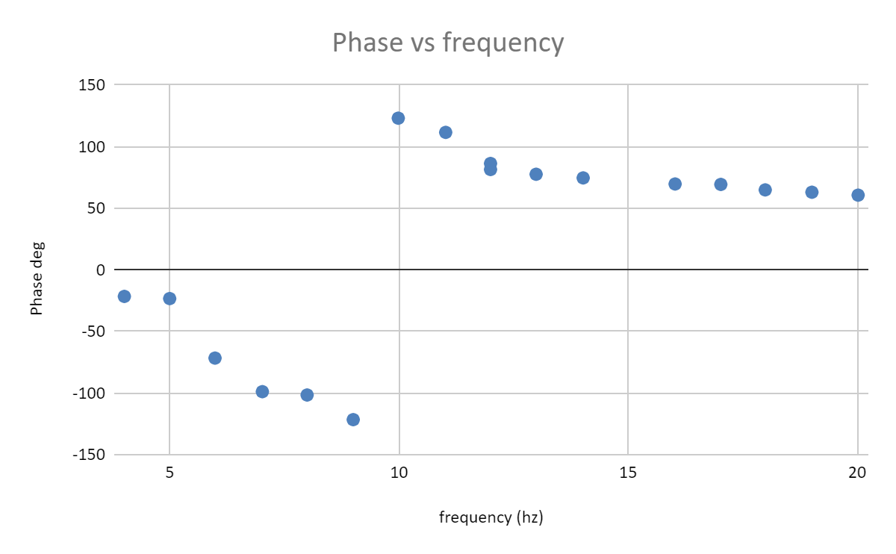

*Figure 6: Phase vs frequency*

# Discussion

## Comparison of Theoretical vs. Actual Values

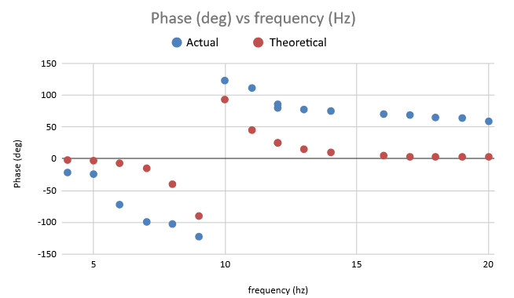

*Figure 7: Phase against frequency responses, theoretical and actual*

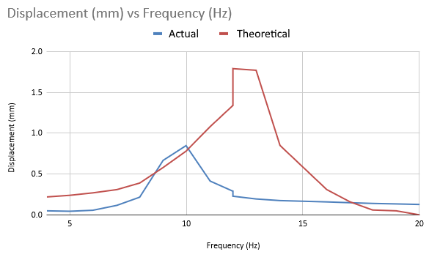

*Figure 8: Displacement against frequency responses, theoretical and actual*

Based on the two figures above, (Figure 7, Figure 8), we can see that the trend that actual values follow closely matches that of the theoretical. However, while the trends appear to be similar, the experimental values appear to be farther apart. This can be attributed to several causes:

* Incorrect assumptions when calculating theoretical values - The calculations performed assumed an ideal system with an equal weight distribution between eccentric masses, a point mass on the end of a single spring (with the constant of each spring multiplied by 4) and damper, and no energy loss other than damping. The values were taken from the lab manual, and we believe there may be some slight variations within the lab equipment itself.
* Misalignment when locating peaks and dips - In LabVIEW, there was some difficulty locating exactly where the peaks and dips were when scrolling with the cursor. Sometimes, the dips were before the falling zero, and other times, after. There were also occasions there the dips had two, or even three maximum points.
* Time constraints - We had issues setting up the equipment initially due to LabVIEW errors. After that, we rushed to complete the lab. This probably had an effect on our results.

# Conclusions

Using a representative system of an automobile engine, crankshaft and piston, we found that the effects of resonating frequencies on damped systems could be quite severe. At these frequencies, the effect of eccentric mass increased significantly causing severe up and down movement in the y direction. Also, at natural frequencies, the system had unpredictable vibrations in all directions. Therefore, it is important to carry out physical tests to confirm vibrations at a range of frequencies and closely compare theoretical and physical systems. On the other hand, the system at frequencies different than the natural frequency, the system was quite stable. This is interesting as it shows that vibrating systems do have a tendency to self correct the vibrations.